# SIMATS LIBRARY RESERVATION SYSTEM

**STEP – 1:**

Create a new application and new form named library management.

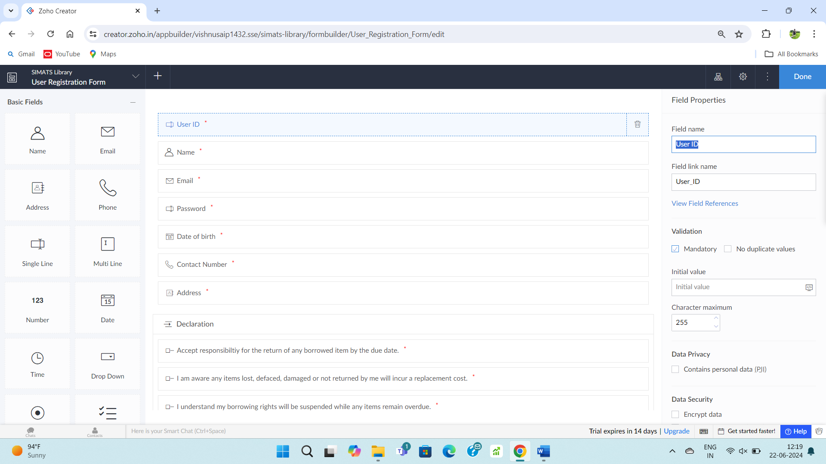

**STEP – 2:**

Fill upon the created form.

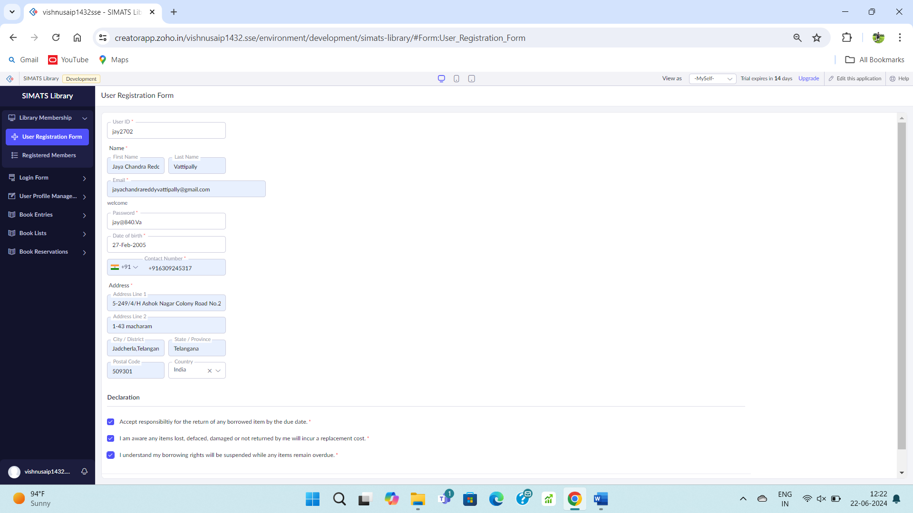

**STEP – 3:**

Go to registered members report form.

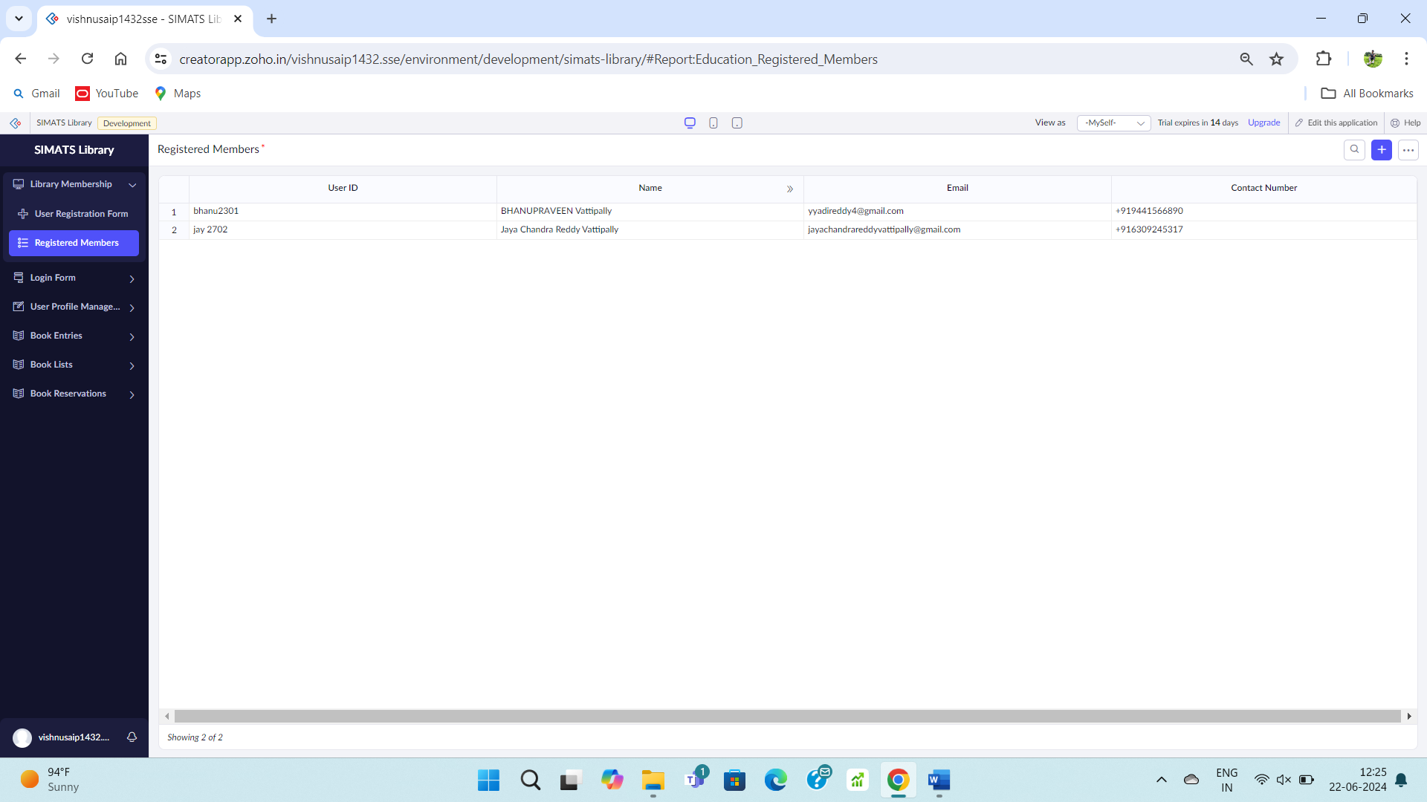

**STEP – 4:**

Create a login form.

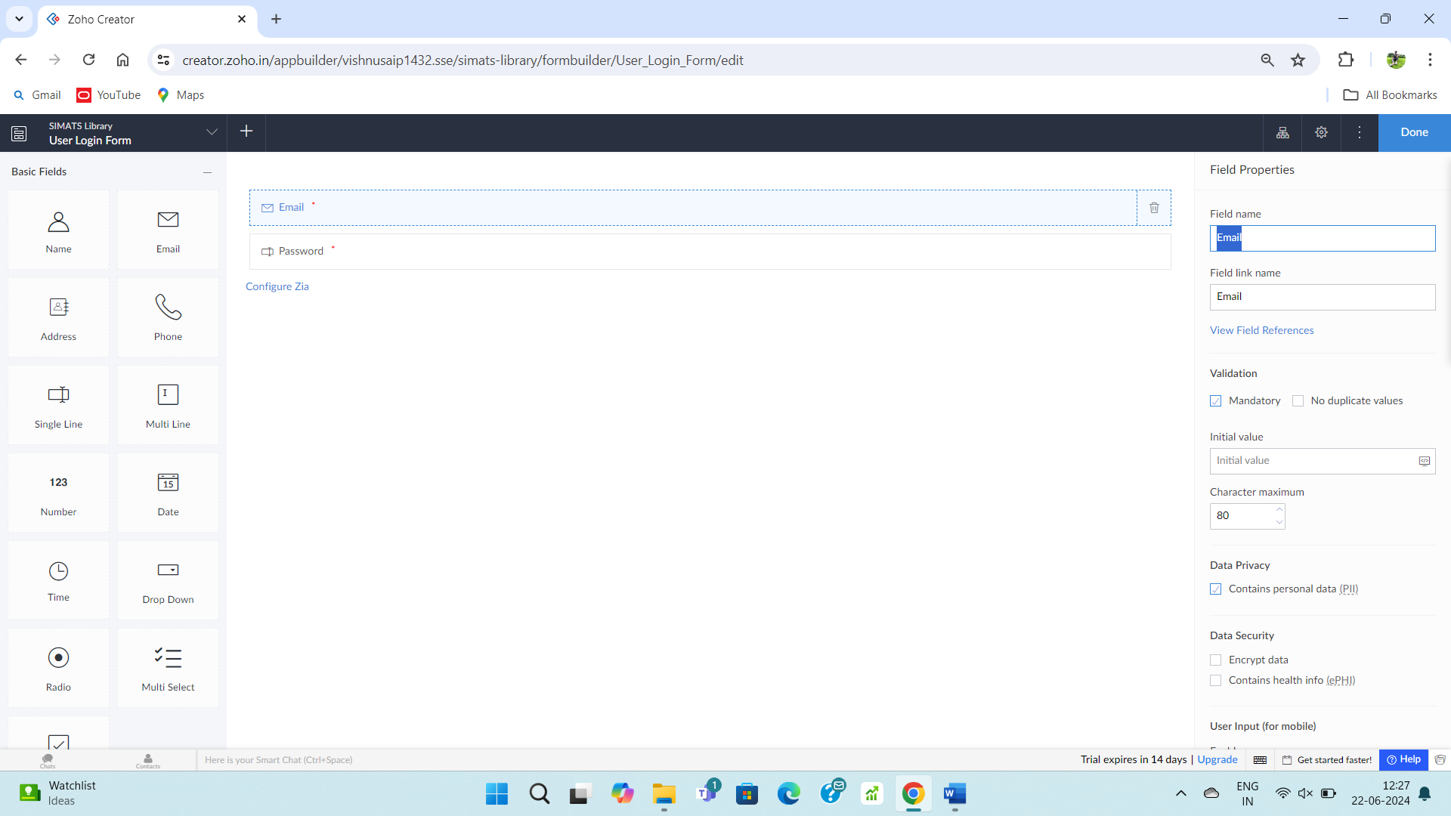

**STEP – 5:**

Fill upon the created form.

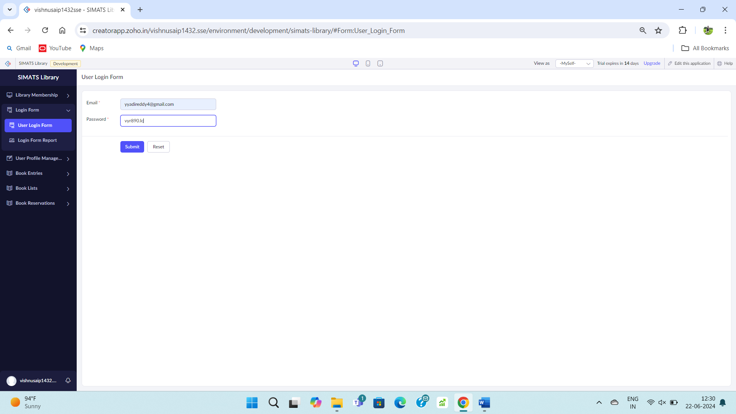

**STEP – 6:**

Go to the login report form.

